###########Nagios WebInterface Screenshots##########

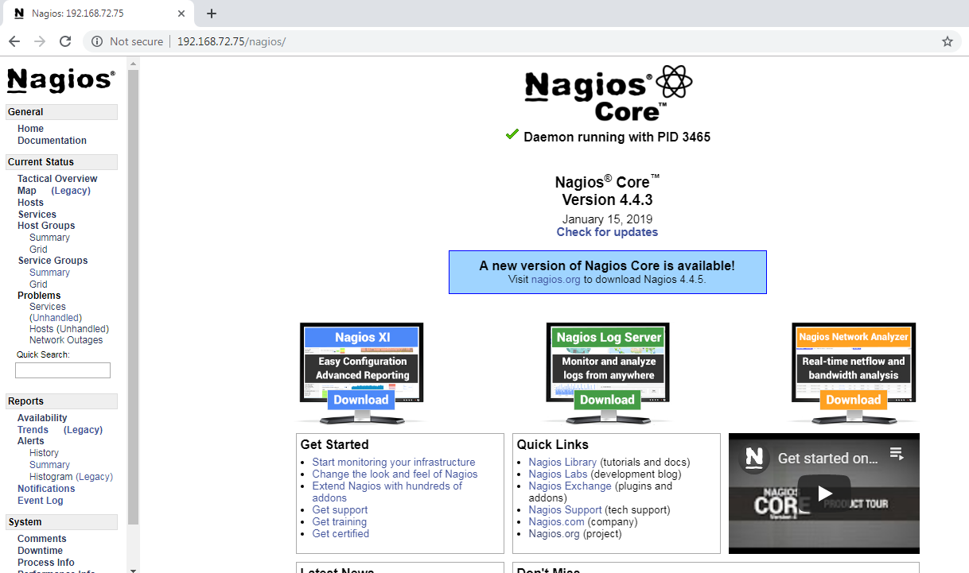

## ######## Monitor the remote machine ############

## Go and check the Nagios web interface to view the new services we added just now.

## 